Functions are Objects:

* First Class Functions: Everything you can do with other types you can do with functions (Assign them to variables, pass them around, create them on the fly).

Everything that you can do with other types i.e. objects, strings, number & Boolean. You can do with functions. You can assign variable to a value that is a function. You can pass functions around as parameters to other functions. You can create functions on the fly with a kind of literal syntax. First class functions change the way you can program. They can open up horizons to completely different approaches to solving problems.

When we say functions are objects in JavaScript, People are surprised when they find out that in Javascript you can attach properties & methods into a function. The function is just an object in JavaScript.

**In functions, you can attach the following:**

Primitive (A name value pair)

Object

Function

In JavaScript the function object has some hidden special properties.

Name - (The optional can be anonymous)

Code - (This is where the actual line of code – You’ve written sits). The code that you write gets placed into a special property of the function object. It isn’t like the code that you write is the function. The function is an object with other properties and the code that you write is just one of those properties adding on to it. What is special about that property is that it’s “invocable ()”. By incvoking, you can say run this code – in other words run the code sitting on that property and that is when the entire execution context gets creation happens.

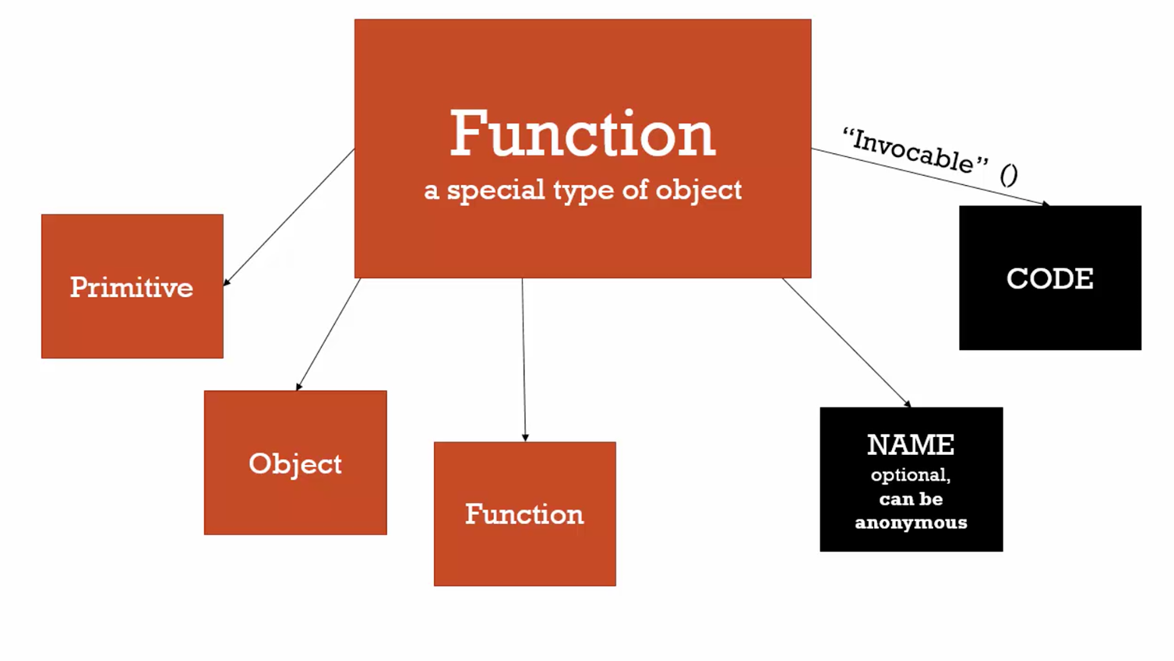

It is impetrative that you can this function model in your mind. As we go through to the rest of this course. You have to think of a function as an object and it’s code happen to be one of it’s properties of that object. There are other things the function can have attach to it and many other things functions can do.

This is very important Concept. It will enable to deeply understand JavaScript rather than someone who just knows little bit of JavaScript.

**Working Example:**

function greet( ) {

console.log('Hi');

}

greet.language = 'English'; /* Look we added a property to a function, which is an object */

console.log(greet); /* this will only display the string of the function object. */

/* Instead if we console.log the property inside greet function object, it will display the result */

console.log(greet.language); /* It will display the property added to the function object */

console.log('the property added inside the function object is called ' + '= ' + greet.language);